HRIS Service Record Module
Template Guide
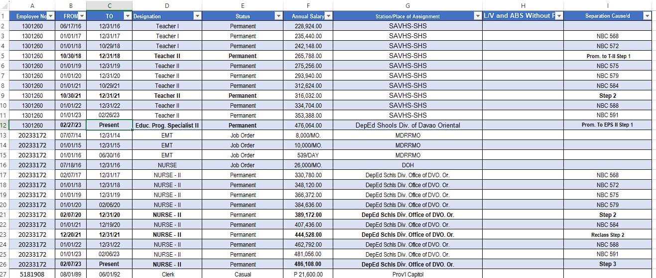
Column A (Employee No.)
- Right-click column A (Employee No.).
- Click Format Cells.
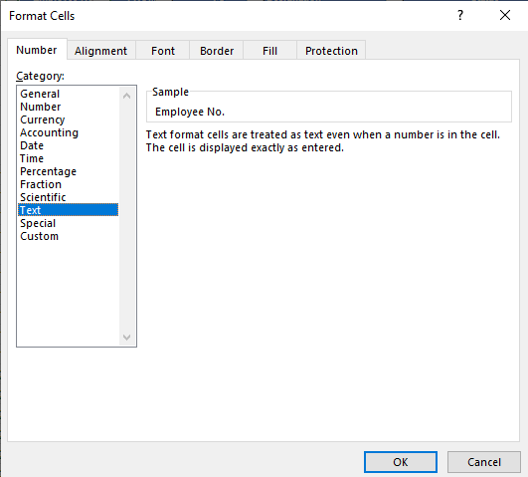

- From the Number tab, click Text.
- Click the OK button.
Column F (Annual Salary)
- Right-click column F (Annual Salary).
- Click Format Cells.
- From the Number tab, click Custom.
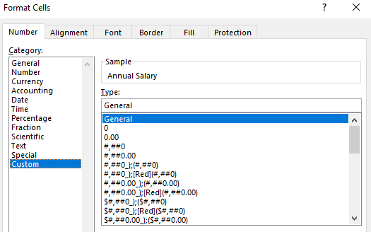

- Scroll down then select this format:
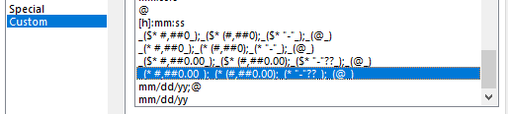

- Click the OK button.
Saving the file to CSV format.
- From the File menu, click Save As.
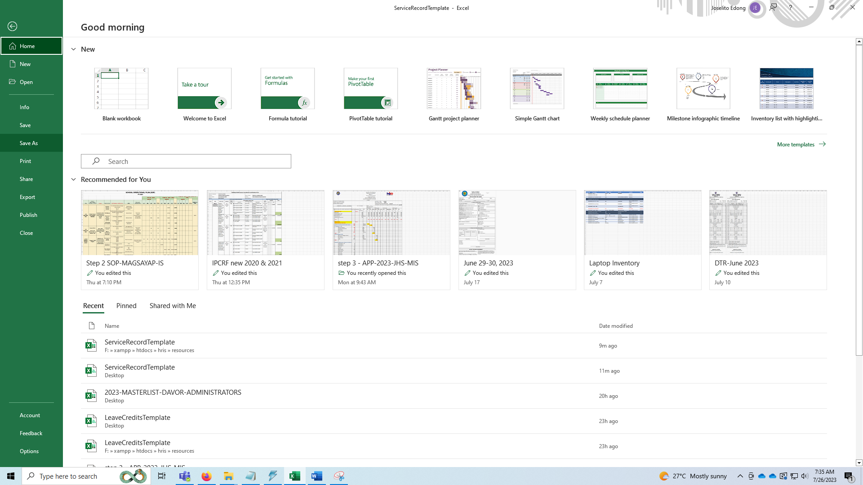
- Locate the directory where you want to save the csv file.
- Under the Save As dialog box, you can see an option Save as type. Select CSV UTF-8 (Comma delimited).
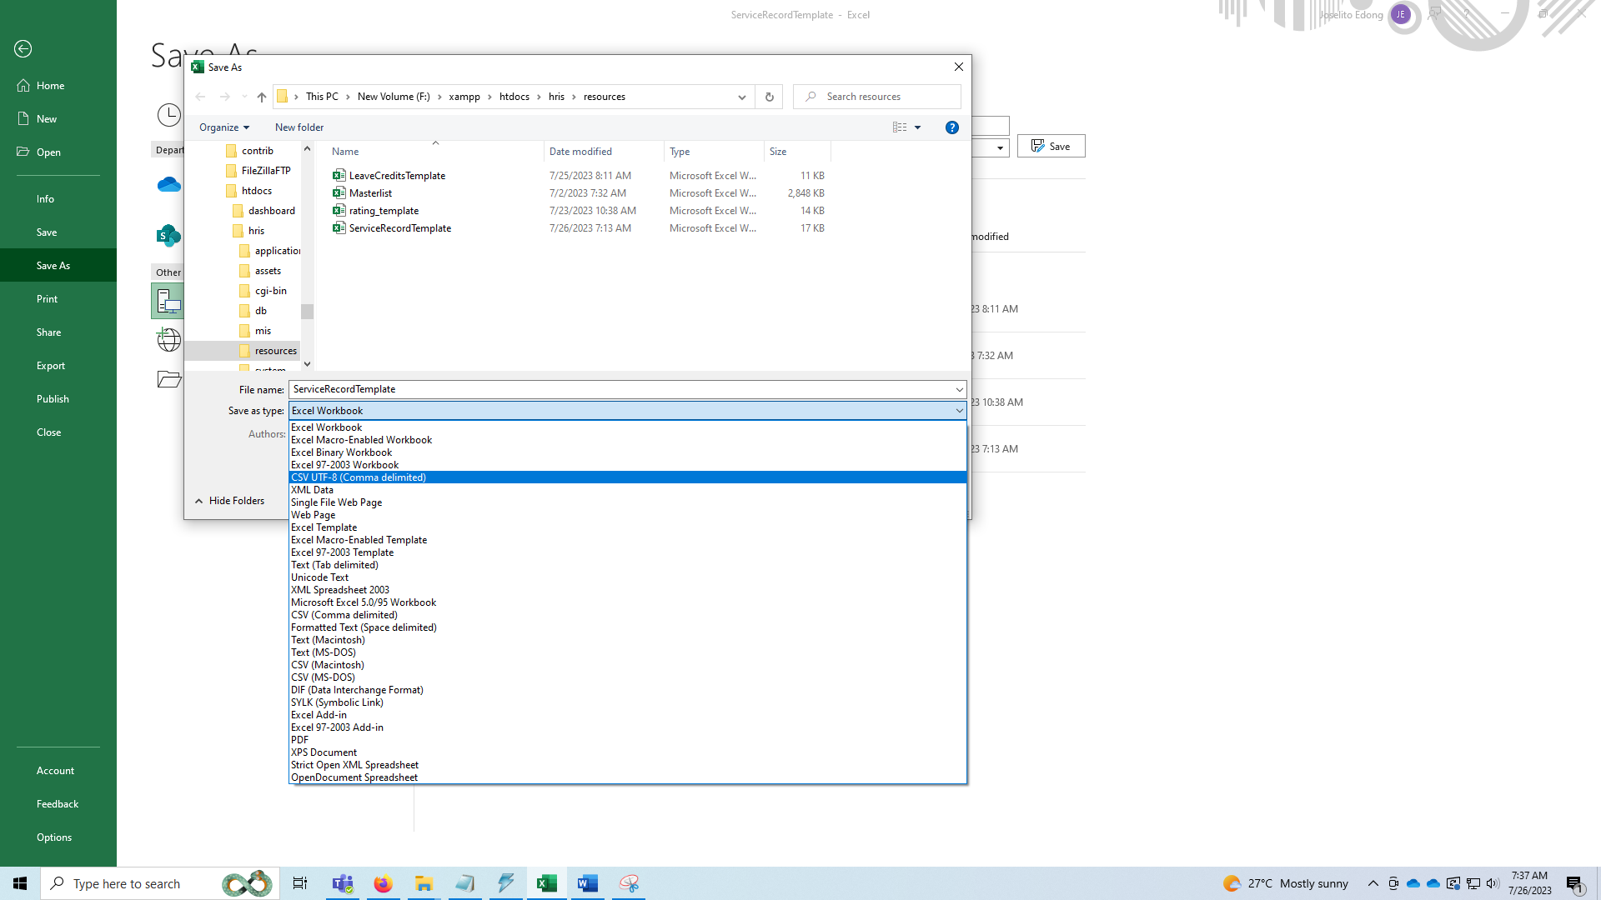

- Click the Save button.
Uploading of CSV File to the HRIS
- Using your HRIS account, login to the system.
- From the sidebar menu, click Service Record >> Bulk Upload.
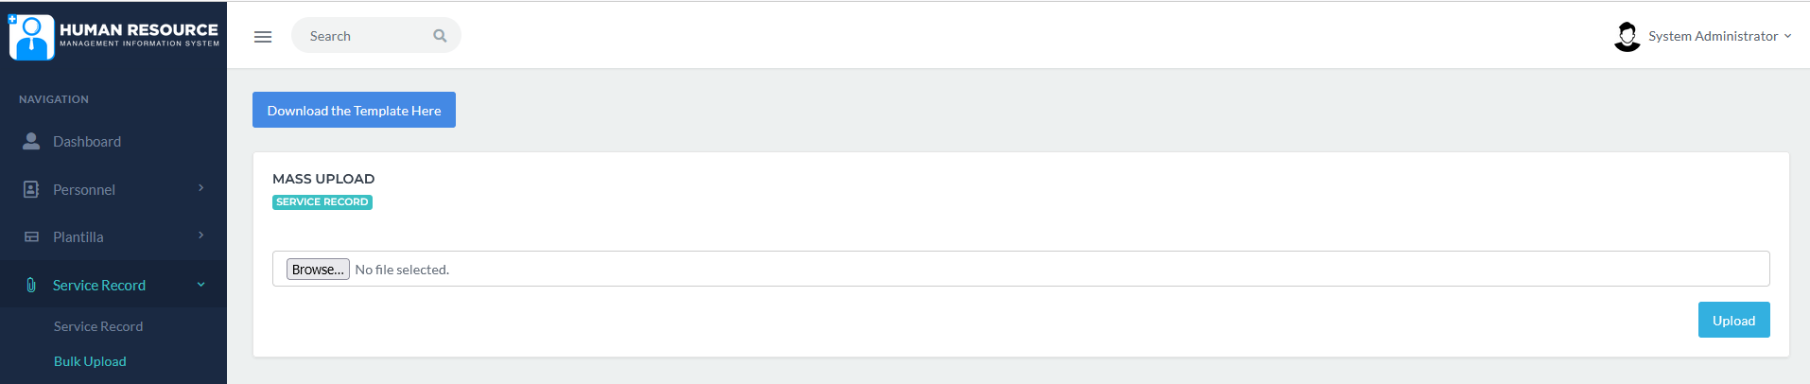

- Click browse, then locate your CSV file.
- Click Upload. A prompt message  will appear on the screen.`

